**Curriculum vitae**

**Persoonsgegevens:**

|  |  |  |
| --- | --- | --- |
| Naam | : | Maikel Boezer |
| Voorletters | : | M.M.J |
| Geb. datum | : | 4 November 2003 |
| Geslacht | : | M |
| Gehuwd | : | Nee |
| Adres | : | straat |
| Postcode & woonplaats | : | plaats |
| E-mailadres | : | email |
| Telefoonnummer  Nationaliteit  Rijbewijs | :  :  : | telefoon  Nederlands  B |

**Opleidingen:**

|  |  |  |
| --- | --- | --- |
| **Periode** | **Opleiding** | **Diploma** |
| 2025 – Heden | Minor CyberStars: cybersecurity. | Certificaat |
| 2022 – Heden | Applied data science and artificial intelligence (HBO) | Ja |
| 2020 – 2022  2020 – 2020  2020 – 2020 | Natuur en techniek (Havo)  Python beginner course Radboud Nijmegen  Kennismaking robotica hogeschool Utrecht | Ja  Plus document  Plus document |
| 2016 – 2020 | Natuur en techniek (Mavo) | Ja |

**Nadere omschrijving van de opleiding(en):**

|  |  |  |
| --- | --- | --- |
| Opleiding | : | Breda University of Applied Science (BUas) |
| Periode | : | 2022-heden |
| *Diploma / certificaat* | : | Studerend 3de jaar |
| Opleiding | : | Willem van Oranje college waalwijk (Havo) |
| Periode | : | 2020-2022 |
| *Diploma / certificaat* | : | Ja |
|  |  |  |
| Opleiding | : | Willem van Oranje college waalwijk (Mavo) |
| Periode | : | 2016-2020 |
| *Diploma / certificaat* | : | Ja, cum-laude geslaagd |

**Werkervaring:**

|  |  |  |  |  |
| --- | --- | --- | --- | --- |
| **Periode**  2025 – 2025  2024 – 2025  2023 – 2024  2023 – 2024  2023 – 2024  2023 – 2024  2022– 2023 | **Functie**  Data engineer & analytics translator  Data engineer (opdracht tijdens studie)  Data engineer (opdracht tijdens studie)  Data scientist (opdracht tijdens studie)  Data engineer/ Data scientist (opdracht tijdens studie)  Reseurser (opdracht tijdens studie)  Data engineer (opdracht tijdens studie) | | **Bedrijf**  Stedin  Breda Guardians/ BUas  NPEC Utrecht/ BUas  Banijay benelux  NPEC Utrecht  BUas  gemeente Breda | |
| 2022 – 2023 | Data scientist (opdracht tijdens studie) | | Banijay benelux | |
|  |  | |  | |
| 2019 – 2019 | Snuffel stage IT dienst verlening | | ReallyIT | |
|  |  |  | |

**Taalvaardigheden:**

|  |  |  |
| --- | --- | --- |
| **Talen** | **Schriftelijk** | **Mondeling** |
| Nederlands | goed | goed |
| Engels | goed | goed |

**De opleiding is engelstalig vandaar dat de uitleg over mijn skills en projecten in het engels is.**

**Skills and software skills:**

* I have around 4 years of experience with Python in these years I have made
  + Machine learning models
  + deep learning models
  + neural networks
  + computer vision(cv) models
  + Natural language processing (NLP) models
* I know how to work with Docker and prepare them to put on a server.
* I have worked with PowerBI to create dashboards for clients.
* I have automated a pipeline from data downloading to data visualization on a dashboard.

**My projects:**

**Dashboard pipeline:**

**AI coach:**

The last project I worked on was about making an AI coach for an E-sports organisation named Breda Guardians which is based in the HIVE at Brade University of applied sciences (BUas). This project is a multi-year project for students of the applied data science and AI (ADS&AI) course, I was part of the first group to work on this project so we had to build everything from the ground up. Because of this, we had to acknowledge that making an AI was not feasible with the time we had to work on this project so we decided to lay the groundwork for the next groups and create a dashboard to show the progress.

We started with data collection, we collected: keyboard and mouse inputs, gaze data, facial expression data, and video data. The input data is collected through a Python script, gaze data with a Tobii eye tracker, facial expressions or emotions with the use of a webcam and a computer vision algorithm provided by open-face and the video is recorded with OBS.

After setting up the data collection we started building a data storage system, we decided on using SFTP for our bulk storage and PSQL for organizing the data. To make sure that everything would work on a server and to make it automatic we made a docker container that is running both the SFTP server and the PSQL server.

The last part of the project is to automate it and make a dashboard. For the automation part, we made it so that when data collection stops it gets uploaded to the SFTP server and that the numeric data then gets uploaded to the PSQL server. Then if the dashboard wants to display some of the data it can find it in the PSQL server.

Below you can see a sort demo of the project.

[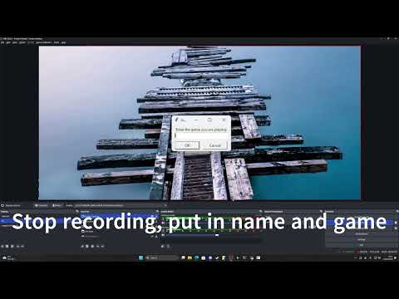](https://www.youtube.com/embed/FPKSHeOVA-E?feature=oembed)

**Computer Vision NPEC:**

For this project, I needed to make a computer vision algorithm that could Isolate the roots of plants, find the coordinates of all the root ends, calculate the length of the main root and then move a robot to those coordinates and water the plants at these points.

The algorithm I used for this is a convolutional neural network or CNN called U-Net. A U-Net model specialises in image segmentation which means that the model works with only segments or parts of the image(1.) instead of trying to process the whole picture at once, one of the reasons to do this is to reduce the workload for so the model is able to run and run faster than other models. The model's output(3.) was not bad either with a little bit of cleaning the picture, and I had something I could work with.

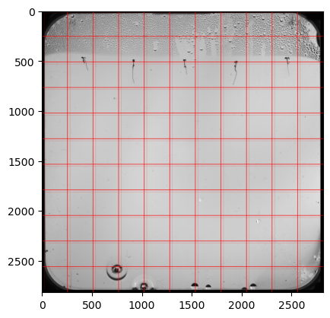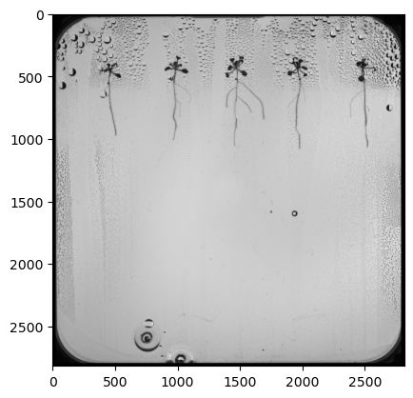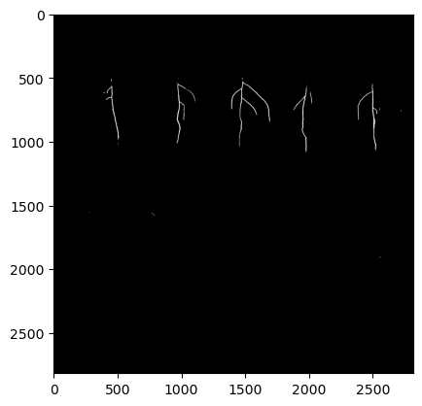

1. How pictures get segmented.

2. Input picture for the model.

3. Output of the model.

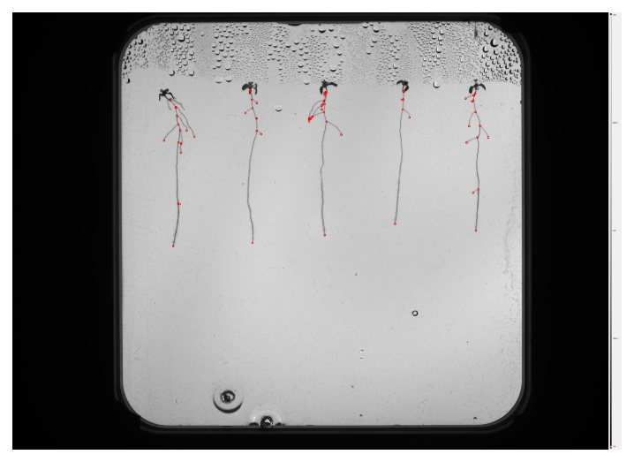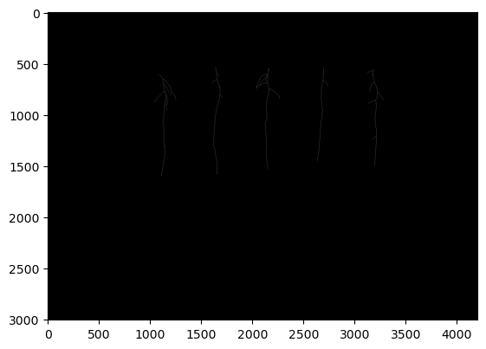With the roots isolated I was able to skeletonize(4.) the image which turns everything in the image into a line or a skeleton of the image, with this I could find all the coordinates of the beginning and end of every root(5.). after this I isolated the roots(6.) and got the length from the main root(7.).

5. Visualization of the coordinates

4. Skeletonized version of the images

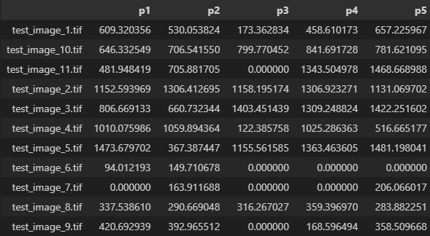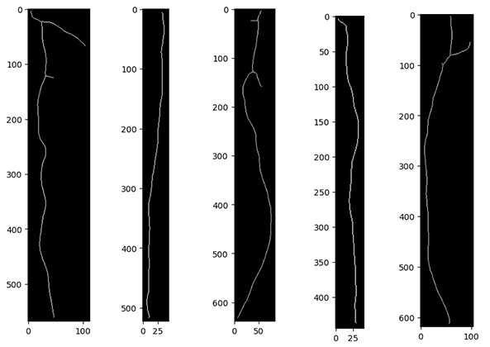

7. Root lengths

6. Isolated roots

For the robotics part of this project, I did not get as far as I would have liked. I got a simulation of the robot that we used for testing moving(8.) but I did not have time to make things automated.

8. Simulation of robot moving